- Bluebook Page163 August 2019 variant three examination:

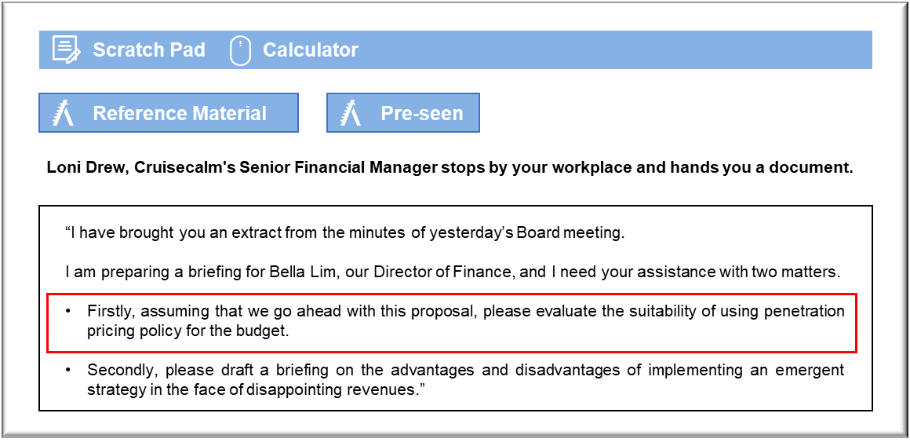

MANAGEMENT CASE STUDY AUGUST 2019 EXAM ANSWERS

Variant3 Task1
These answers have been provided by CIMA for information purposes only. The answers created are indicative of a response that could be given by a good candidate. They are not to be considered exhaustive, and other appropriate relevant responses would receive credit.

CIMA will not accept challenges to these answers on the basis of academic judgement.

Requirement 1: Penetration pricing
Cruisecalm is considering a new product that will be marketed on the basis of its low price and so penetration pricing might be a good way to build presence in this market. Penetration pricing normally leads on to price increases once a market base has been established, but that will not necessarily be the case here. The budget cruise operation could continue as it is initially established, providing it proves profitable. Cruisecalm is considering this pricing model in response to declining bookings and it will now have the opportunity to observe whether a reduction in selling prices has any impact on demand.
The most immediate concern is that the proposed changes will not offer sufficient cost savings to make it possible for Cruisecalm to reduce its selling prices sufficiently to make a real difference.
The monthly operating statements of MV Krono and MV Batvia show monthly payroll costs of N$2.4m and N$2.3m respectively, which are relatively small proportions of the monthly operating costs. Even if payroll could be reduced by half, it would not create a great deal of scope for reducing cruise prices.
Penetration pricing could be difficult to implement because Cruisecalm’s two principal
competitors are already occupying the low-cost segment of the cruise market. Passengers who have travelled with Wavelyne and Saildine in the past may be inclined to rebook with those companies rather than risking switching to Cruisecalm’s new product, which may prove disappointing. Cruisecalm may be forced to sell low-cost cruises at a loss, at least initially, in order to penetrate this segment of the market. In which case, it may make more sense to offer its existing services at a reduced cost in order to rebuild volume.
The product may also compete directly with Cruisecalm’s conventional cruises and further reduce the volume of bookings on those. Passengers will be cruising on the same ship as before, possibly eating the same food if they would have opted for the buffet restaurant and with a slightly less elaborate stage show. If the price of the “no-frills” package is sufficiently low to compete with Wavelyne and Saildine then Cruisecalm’s existing passenger base may be very tempted to experiment with the low-cost option.
Requirement 2: Emergent strategy
The first advantage is that an emergent strategy can free the Board of the constraints that might be imposed by intended strategies that have been set in the past and have reflected the business environment that was in place at that time. The Director of Marketing’s proposal is intended as a
These answers have been provided by CIMA for information purposes only. The answers
created are indicative of a response that could be given by a good candidate. They are
not to be considered exhaustive, and other appropriate relevant responses would
receive credit response to declining bookings, which are a clear indication that the intended strategy is not working as well as would be hoped. The proposal to offer low-cost cruises is, at least, a response to the possibility that traditional cruises have become too expensive to attract previous levels of custom.
The freedom to follow emergent strategies can offer scope for adaptation in responding to
changes in the business environment that may be rendering the existing business model
unsuitable. In this case, Cruisecalm is faced with declining bookings, which could suggest that the original intended strategy of maintaining quality in return for high selling prices is threatening the company’s future. The proposed low-cost venture will require very little investment and, in this case, has the advantage of being easily reversible.
Emergent strategies can be sources of resistance and instability. Senior members of the management team may feel the need to resist strategies that seem to diverge or distract from the intended strategy. If there is sufficient resistance from key members of the management team then the new strategy venture could fail through a lack of management support, rather than because of limitations of the concept itself.
The pursuit of emergent strategies could prove a distraction from the successful pursuit of the intended strategy. In this case, the Board has not conducted any detailed investigation into the causes of the disappointing booking figures. There is no guarantee that cutting prices will stimulate demand. It might be more realistic to establish why the intended strategy is not working before experimenting with ventures that will take time and will commit resources.

